Totaal Software



Manual
Subjected version: 2000.1.20
Date: February 2002

Language 2
Division of tasks 2
Installation 3
Configuration 5
Working area 19
Data input 26
Data processing 33
Publications 50
Registration 52
Support 55
UCI compliance 58
Miscellaneous 59
Tools 62

This document contains instruction information for the use of the StageRace software product.
This information corresponds to the information contained in the online help system of the product.

Language

The default language of the StageRace program is English. However, when one runs StageRace in an environment with Dutch as the basic language, StageRace will adapt to that.
The Windows® default language can be changed with the use of International settings in the Control panel.
At the installation of StageRace, the help files will be installed in all available languages. During the installation, but also during the use of the program (Tools|Options...), there can be switched between the different languages.

Division of tasks

It is a good thing to make a division into (the moment of execution of) the following tasks.
- Configuring of an event. This can be done in the days preceding to the event, in cooperation with an organization representative. (Page 5.)
- Utilisation of an event. This takes place during the happening of the various stages, in cooperation with the members of the jury which are present. (Page 33.)

Installation

System requirements

In order to make use of StageRace in a proper way, the following system requirements are posed:
- Pentium® PC with Microsoft® Windows® 95 or Microsoft® Windows® NT 4.0 or any newer version of either one, 5Mb free disk space and CD-ROM drive.
- Microsoft® Internet Explorer 4.0 or up has to be installed.
- Screen settings at 800x600 resolution or up.
Parallel port (can be in use already) or free USB port available.

File type

StageRace uses its own file type for the storage of all relevant data: *.str.
During installation, this file type will be registered in Windows® in order to allow you to open StageRace automatically by clicking an STR file, anywhere in Windows®.
Almost all StageRace output takes place with HTML, that is internet files. These HTML files confirm with the latest HTML specification and so they can be viewed with every internet browser, but with the presentation frame of StageRace as well, naturally.
However, also competitor lists can be generated in text format for use with ChronX identification and OPTIc, FinishLynx or Scan'O'Vision photo finish software.

Program installation

The StageRace installation will be supplied as one single file (autorun.exe or stagerace2000xxx.exe). This program will unpack all files and start the actual installation. The rest of the installation is completely in accordance with all common installation programs for Windows®. Below there is a short overview of its exact tasks.
- Copying program files: program files, example files and help files will be copied into folders of which the root folder can be chosen during the installation program.
- Adjusting Windows® registry: a set of keys will be added to the registry. Here StageRace saves information, which improves the comfort of use of the program.
- Installation of the device driver for the hardware key. This is necessary for the use of the software in combination with the hardware key, as a result of which the evaluation mode will be raised. Installation of this part is not necessary for evaluation and can be skipped during the installation.
By use of Add or remove components in the Software part of the Control Panel, StageRace can be removed from the computer system entirely.
Without agreeing to our License agreement (page 54) it is not allowed and thus not possible to install our software.

Configuration

Stage race configuration

The following text is essential for a good knowledge about the construction of StageRace.
An event consists of a number of full stages or days (page 8).
Every full stage consists of one or several half stages (page 9). This means that also for a day on which only one stage takes place, a full stage with only one half stage within will be constructed.
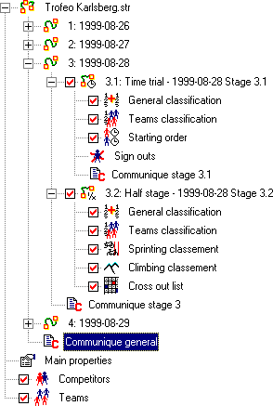
The entire event will be displayed within StageRace as a tree structure (page 19). At the top level one finds the main event, information on the main event (page 13), the competitors and the teams.
The event consists of one or several stages. Every stage consists of one or several half stages. The main event as well as every part of it can consist of one communiqué. Half stages can also consist of entities like sprints and sign-outs, general, team and masked classifications, as well as cross out lists.
A half stage can appear in different forms, namely a normal half stage and a time trial. For a time trial there is always a time trial order.

Masking

Masking means that groups of competitors can be hidden from classifications. Masks can be used to get youth or region classifications. StageRace supports a maximum of three masks per event.
Masking comes into play and can be set up within StageRace at the following places:
- Settings, tab sheet Trialdat: use of the various masks plus the names to be applied
- Settings, tab sheet Presentation: set up the printing of the various masks plus the indicators to be used for competitors lists
- Competitors dialog: select competitors to be part of the masked groups
- Competitor lists: possibly masked competitors are indicated (look at Presentation)
- Masked classifications: can be found in the tree structure, as soon as calculated
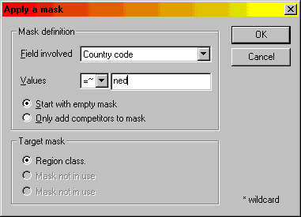
In order to quickly connect a certain part of the competitors to a mask, a handy function is added to Competitors, which is explained below. With this a character string can be compared with the contents of one of the fields of a competitor.
The mask is defined by entering a character string and by choosing with which field it has to be compared.
The type of the comparison can be determined, from the following possibilities:
- "<=": The value of the field is smaller or equal to the value of the character string
- "==": The value of the field is entirely equal to the value of the character string
- "=~": The field exists in the character string or reverse
- ">=": The value of the field is larger or equal to the value of the character string
The comparing of character strings takes place on the basis of the order of the ASCII standard. Start numbers will obviously be compared on numerical value. An asterisk can be used to ignore corresponding positions in character string and field.
The choice can be made to start with an empty mask, but also only to add new competitors to the mask.
The involved mask can be chosen from the activated masks.

Communiqué numbering

Communiqué numbering means the numbering of publications as required by the UCI (2.2.090 en 2.2.091).
Communiqué numbering comes into play and can be set up within StageRace at the following places:
- Settings, tab sheet General: switching on or off the use of communiqué numbering, having effect on the following components
- Check boxes in tree frame: documents effectively released for publication can be indicated. A communiqué number has to be chosen for the particular item before publication can be checked. The chosen communiqué number may not be in use already
- A communiqué number can be assigned to a document by stepping towards the number desired, in the Communique no. bar. Numbers, already in use with published communiqués, will be skipped
- On published documents, the communiqué number will be printed as soon as they are regenerated
Why can StageRace not number my publications automatically? The way as it is, it is possible to insert external publications. For instance very exceptional classifications or informative race reports can be foreseen with a communiqué number that nevertheless fits into StageRace's communiqué numbering nicely.

Configure

Add or remove full stage or day

The actions as described here, can also be executed through a tool bar. To do so, activate the tool bar Configure toolbar in the View menu.
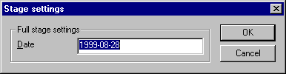
To add a new stage or day, choose Insert|Full stage... in the Configure menu.
The date of the particular stage or day will be asked now. Enter an informative text here. Most often the name of a holiday is preferred above the actual date.
As soon as this dialog is exited with either OK or [ENTER], the particular stage or day is added at the bottom of the tree structure.
It is not possible to insert new stages or days between existing stages or days.
The following step should be to add half stages into the particular stage or day. One can choose between a normal half stage and a time trial.
A full stage date can be edited by choosing Configure selection... in the Configure menu after selecting the particular stage in the tree structure.
An entire stage or day can be deleted by choosing Delete... in the Configure menu after selecting the particular stage or day in the tree structure. A confirmation will be asked for.

Add or remove half stage

The actions as described here, can also be executed through a tool bar. To do so, activate the tool bar Configure toolbar in the View menu.
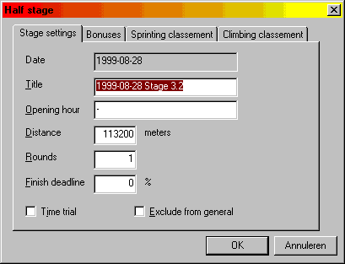
Select the stage or day for which a half stage has to be made. Add a half stage by choosing Insert|Half stage... in the Configure menu.
A dialog will appear in which a number of parameters can be entered.
The following parameters can be entered:
- Title of the half stage.
- Starting time of the half stage.
- Distance and number of rounds: number of rounds should always be one or more, so with city-to-city events, the number of rounds is equal to one and the total distance will be entered directly as is.
- Finish deadline.
- Time trial.
- Exclude from general: allows to have the stage arrival not to be added to the general classification and the cumulative distance. This can be useful for some forms of team time trials. Bonus seconds etc. are nevertheless counted as before.
As soon as this dialog is exited with OK or [ENTER], the particular half stage is added at the bottom of the half stages' list within the particular stage or day. Under the particular half stage, items are added for General classification, Cross out list, possible Masked classifications, Team classification, Sprint classification and Climb classification.
Whenever a time trial is concerned, also a Starting order item is added in the tree. With a time trial, the number of rounds is always one.
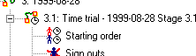
It is not possible to insert new half stages between existing half stages.
A half stage can be edited by choosing Configure selection... in the Configure menu after selecting the particular half stage in the tree structure.
A half stage can be deleted by choosing Delete... in the Configure menu after selecting the particular half stage in the tree structure. A confirmation will be asked for.

Configure bonuses

The configuration of bonuses will be done by use of the tab sheet Bonuses at the configuration of the particular stage.
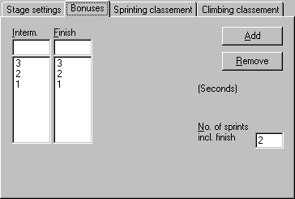
On the tab sheet there are two lists: Interm. and Finish to enter the bonus seconds for the intermediate sprints and the finish respectively.
The bonuses in these lists correspond to the successive rankings, starting from 1.
To add bonuses, the number of seconds has to be entered in the field above the particular list and Add has to be clicked.
If a bonus is selected from the list, it can be deleted by clicking Remove.
Also the number of bonus sprints has to be entered. This is including the finish. Thus, for three intermediate sprints, for instance, a number of 4 should be entered here.

Configure sprint classification

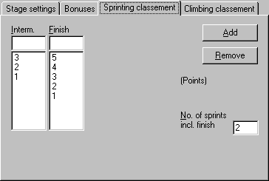
The configuration of sprints will be done by use of the tab sheet Sprinting classement at the configuration of the particular stage.
On the tab sheet there are two lists: Interm. and Finish to enter the points for the intermediate sprints and the finish respectively.
The bonuses in these lists correspond to the successive rankings, starting from 1.
To add points, the number of points has to be entered in the field above the particular list and Add has to be clicked.
If a line with points is selected from the list, it can be deleted by clicking Remove.
Also the number of points sprints has to be entered. This is including the finish. Thus, for three intermediate sprints, for instance, a number of 4 should be entered here.

Configure climb classification

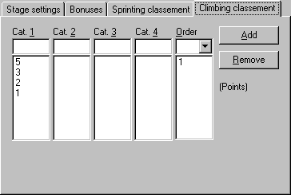
The configuration of the climb classification will be done by use of the tab sheet Climbing classement at the configuration of the particular stage.
With a climb classification, the various sprints will be divided in different degrees of difficulty.
At the tab sheet as much as five lists can be found, of which four correspond to four degrees of difficulty or categories. These lists consist of the points given at those particular categories.
The points in these lists correspond to the successive rankings, starting from 1.
To add points, the number of points has to be entered in the field above the particular list and Add has to be clicked.
The last list consists of the overview of the various sprints. This list can consist of the numbers 1, 2, 3 and 4 only, depending on the difficulty of every sprint.
To add a sprint, the number of the desired category has to be entered in the field above the Order list and Add has to be clicked.
If a score or a sprint is selected from any list, it can be deleted by clicking Remove.

Configure selection

Through Configure selection... in the Configure menu, it is possible to change the parameters of the item currently selected in the tree structure.

Settings

Through Settings... in the Configure menu, it is possible to change a number of settings for the particular event.

Settings trialdat

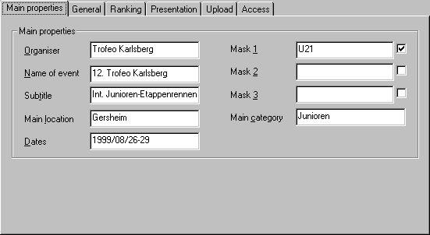
At the Traildat tab sheet, accessible from Settings... in the Configure menu, it is possible to enter a number of informative characteristics of the particular event.
- The settings on the Trialdat tab sheet are the following:
- Name of the organiser.
- Name of the event and a sub title.
- Main location of the event.
- Description of the period in which the event takes place ("Easter weekend", "June 2nd-June 4th").
- The most important category of competitors that participates.
- The description and the activation of three masks. These masks can be used elsewhere to isolate a part of the riders. This way there can be separate classifications for youth riders or regional competitors. At this spot one can give a description and switch the particular classification on.

Settings general

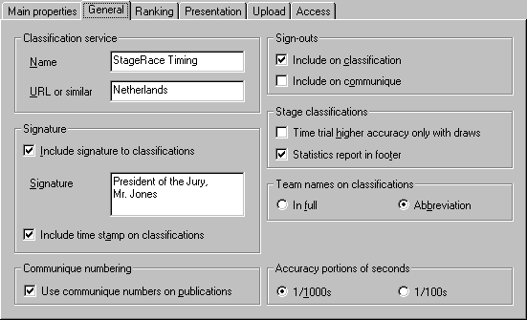
At the General tab sheet, accessible from Settings... in the Configure menu, it is possible to enter a number of general settings for the particular event.

The settings on the General tab sheet are the following:
- Name and one extra informative line about the party that is in charge of the classification service for the particular event. This information will be printed as advertising at the bottom of all publications, together with information about StageRace.
- The choice either to print or not to print a signature below all publications. The entered signature can be name plus title of the chairman of the jury, for instance.
- The choice either to print or not to print a time stamp below all classifications.
- The choice either to print or not to print the sign-outs of competitors at respectively classifications and communiqués.
- The choice only to print higher accuracy (portions of seconds) at time trials when there is a draw in the full seconds. On default time trial results are printed with a 1/1000s accuracy.
- The choice either to print or not to print a statistics report in the footer of publications (2.2.091). Not printing these reports can be required if the jury decides not to include all the competitors (of the last stage) in the classification, resulting in the statistics not to be accurate.
- The choice either to print team codes (2.2.091) or full team names on publications.
- The choice either to use 1/1000s or 1/100s for entering the portions of seconds. This is used in the window where classifications are entered (normal half stage and time trial), to improve the comfort of use.
- The choice whether or not to use communiqué numbering for this event.

Settings ranking

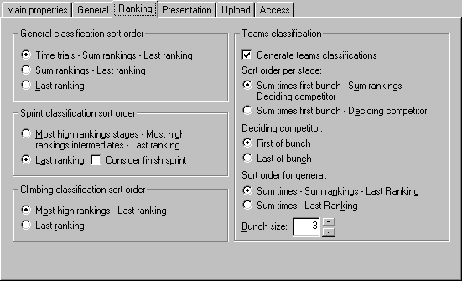
At the Ranking tab sheet, accessible from Settings... in the Configure menu, it is possible to enter a number of settings concerning the calculation of classifications for the particular event.
The settings on the Rankings tab sheet are the following:
- The way in which the general classification has to be assembled is according to the following rules, in descending order of priority.
For the general classification, all ridden times will be added, where times will be rounded down (2.3.041 en 2.4.015).
In case of a draw, more accurate registrations during time trials can be taken into concern (2.6.015).
In case of another draw, the rankings of all stages can be added (2.6.015).
If this still results in a draw, the ranking of the last classification will be taken as a final resort (2.6.015).
To indulge to exceptional arrangements, it is possible to dismiss rules 2 and 3.
- • For the sprint classification it is possible to sort it on the highest number of highest rankings, in case of a draw. (A competitor with three number one rankings wins in that case from for instance a competitor with two number one rankings.) As a last resort, the competitor wins, who was the last to get his last points. For the sprint classification, the choice can be made either to consider or not to consider points gained at the stage arrival.
- For the climb classification it is possible to sort it on the highest number of highest rankings, in case of a draw. (A competitor with three number one rankings wins in that case from for instance a competitor with two number one rankings.) As a last resort, the competitor wins, who was the last to get his last points.
- For teams classifications it is possible to switch teams classifications generation on or off. Teams classifications are calculated, based on the gross arrival times from the (every team's) best-ranked competitors bunch in every stage. When switched on, the following settings are possible:
If a draw in the stage teams classification occurs, there is the possibility to sort on the sum of the rankings of the competitors bunch involved. As a last resort, the ranking of the deciding competitor is taken into account.
The deciding competitor can be chosen to be the first or the last of the competitors bunch involved.
If a draw in the general teams classification occurs, there is the possibility to sort on the sum of the rankings of the teams in all stage teams classifications. As a last resort, the ranking in the last stage is taken into account.
The size of the bunch that is considered can be set to 2, 3 or 4.

Settings presentation

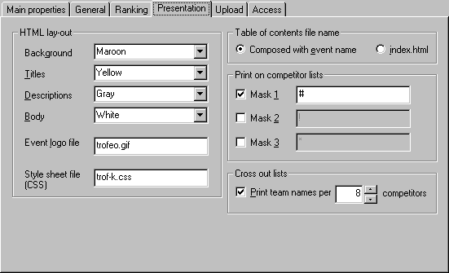
At the Presentation tab sheet, accessible from Settings... in the Configure menu, it is possible to enter a number of settings concerning the lay-out of the publications of the particular event.
The settings on the Presentation tab sheet are the following:
- The colours for respectively the background, the big titles, the labels at the several fields and the body text.
- The file name or internet location that points to an image that should be shown at top of all publications of the particular event.
- The file name or internet location that points to a cascaded style sheet to overrule the default StageRace style settings of all publications of the particular event.
- The choice to name the file for a generated Table of Contents 'index.html' or in accordance with all other publication file names (composed from the event title). Setting this to 'index.html' also will cause alerts to arise when you are displaying the Table of Contents in the presentation frame or when uploading files to a web server, since an available 'index.html' not necessarily matches the event in subject.
- The choice to print the various masks on the competitors and teams list. When one of those masks is selected to be printed, an appropriate text can be chosen to be printed there. For instance: "#" or "U21" but HTML text like "<IMG SRC=logo.gif WIDTH=21>" is allowed as well. The choices made here only apply if the particular mask is activated on the Settings trialdat tab sheet.
- The choice to include team names on cross-out lists as well as the number of competitors per team, ergo per line. If chosen not to print team names, always ten competitors per line are printed.

Settings upload

At the Upload tab sheet, accessible from Settings... in the Configure menu, it is possible to enter a number of settings concerning the copying of publications to an internet location. These settings are used when the Upload... function in the File menu is chosen.
For this copy function a FTP connection will be established with a server. For this a user name and a password are usually needed. A directory name can be supplied in which the files have to be copied.
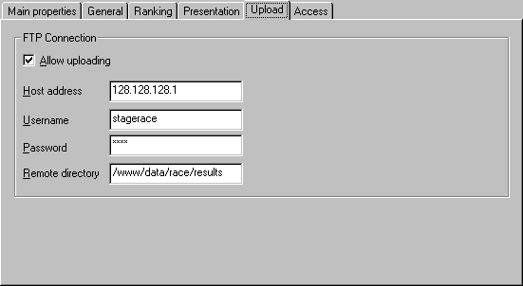
The settings on the Upload tab sheet are the following:
- Either allow or prohibit the use of the upload function.
- The name of the remote FTP server.
- User name and password for the FTP server.
- The target directory on the FTP server.
Note that with an upload all *.html files belonging to the project, are copied onto the FTP server.

Settings access

At the Access tab sheet, accessible from Settings... in the Configure menu, it is possible to protect the configuration of the particular document.
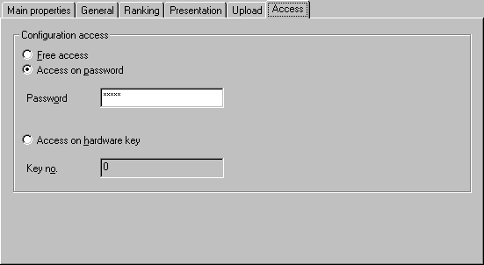
With protection it is no longer possible to alter the main characteristics of an event. This can be necessary to enforce a good division of tasks between configuration and utilisation of an event, as described elsewhere.
There are three possible protection settings:
- No protection.
- Password protection. As soon as a user chooses to alter the configuration settings, a password will be asked. Note that no spaces are allowed. Accordingly, these will be removed!
- Protection by hardware key. As a result, the file is only configurable if StageRace runs with the same key with which the protection was initiated.
The protection of the document is only a protection of the configuration settings. Data input and processing will remain possible as normal.

Working area

Tree frame

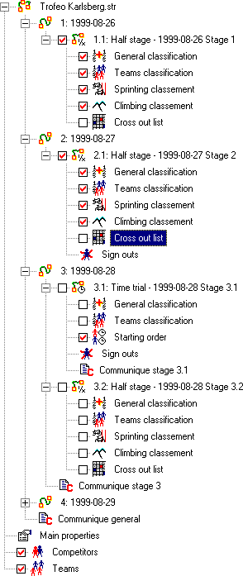
The configuration of an entire event will be displayed in the form of a tree structure in the left half of the program working area.
At the root of the tree, the name of the event's file name can be found. Also the competitors, teams and general information on the event can be found at the top level. Inside the tree the stages and half stages are located.
Additionally, half stages can consist of items, such as sprints and sign-outs, general, team and masked classifications, as well as cross out lists.
Tree items can be selected and subsequently edited with the use of the various menus and tool bars.
When communiqué numbering is selected in the Settings general (page 14), all tree items representing documents are equipped with check boxes to publish these documents.

Presentation frame

All StageRace output is in the form of separate files of the HTML (page 3), that is internet file type. These files will be displayed in the right half of the program working area (the presentation frame).
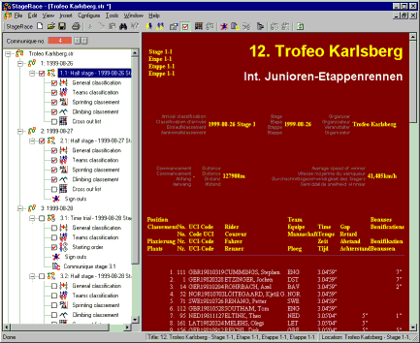
Depending on the current selection in the tree frame the presentation frame will display either a competitors list, a classification or something similar.
When for instance a stage is selected in the tree frame, the matching classification will be displayed in the presentation view.
The status bar at the bottom of the program working area will display the title and the file name of the displayed HTML file.
The displayed file in the presentation frame can be printed with Print... in the File menu.
Text within the presentation frame can be searched for with Find... in the Edit menu.

Menus

Through the menus at top of the program working area, all StageRace's functions can be accessed. Here the functions will not be discussed thoroughly since this information can be found elsewhere.

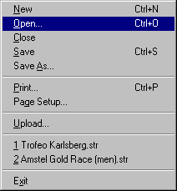
File
- Functions for opening and saving of StageRace files. The StageRace file type is *.str (page 3).
- Page setup (page 51) and the print function to print the contents of the presentation frame.
- Upload function to copy files to an internet server (page 17).

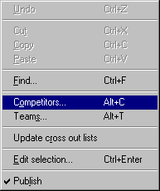
Edit
- Instant editing of competitors (page 26) and teams (page 29).
- Text search within the presentation frame (page 20).
- Regeneration of all cross out lists (page 50).
- Editing of the current tree frame (page 19) selection.
- Publishing a document (page 7) or undo a previous publication

View
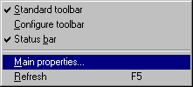
- Switch the various tool bars (page 24) on and off.
- Display the main trialdat of the event (page 13).
- Refresh the presentation frame (page 20).

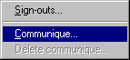
Insert
- Insert communiqués (page 49) and sign-outs (page 48).

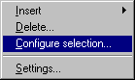
Configure
- Add stages (page 8) and half stages (page 9) in the tree frame (page 19).
- Remove any selected item from the tree structure (page 19). A confirmation will be asked for.
- Configuration of the selected item in the tree structure (page 19). (This is not equal to Edit selection... from the Edit menu!)
- Access a window for making various settings of the event (page 13).

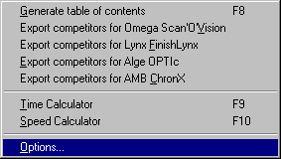
Tools
- Export competitors to Omega Scan'O'Vision, Lynx FinishLynx, Alge OPTIc and AMB ChronX file formats.
- Generating a table of contents for all (published, page 7) documents.
- Practical tools: the time calculator (page 63) and speed calculator (page 63).
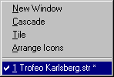
- The options window (page 60).

Window
- Various known Windows® functions for the simultaneous use of different StageRace events.

Help
- Access the help functions.
- Information about StageRace.

Tool bars

In general, all functions from the menus (page 21) are available in a number of tool bars.
Every tool bar exists of a number of buttons. Whenever a button is clicked, the button's function will be displayed in the status bar at the bottom of the program working area.
The following tool bars are available:
- Standard toolbar: functions from menus File, Edit, View, Insert and Tools.
- Configuration toolbar: functions from menu Configure.
The standard and configuration tool bars can be switched off from the View menu.

Accelerator keys

The following accelerator keys are available within StageRace:
Ctrl+Enter, Alt+Enter | Edit current selection
F5 | Refresh presentation frame's contents
Tab, Shift+Tab, F6, Shift+F6 | Switch between frames
Alt+C | Edit competitors list
Alt+T | Edit teams list
Alt+L | Update cross-out lists
Alt+P | Publish
Alt+Q | Communique
Alt+S | Sign-outs
Ctrl+N | Construct new file
Ctrl+S | Save file
Ctrl+O | Open file
Ctrl+P | Print current presentation frame's contents
Ctrl+F | Do text search in current presentation frame's contents
F1 | StageRace Help
F8 | Generate table of contents
F9 | Time calculator
F10 | Speed calculator

Data input

Competitors

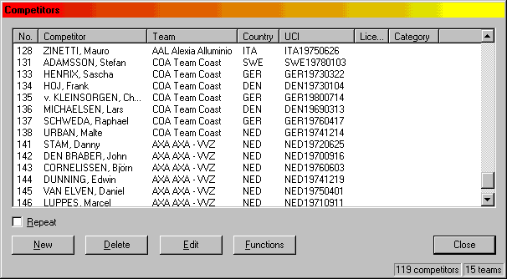
To edit the competitors list, choose Edit|Competitors..., double click Competitors in the tree or click the appropriate standard tool bar icon.
The competitors list window consists of the following items:
- The competitors list
The width of the columns can be adjusted by dragging the little separation line between two column headers. The various columns can be rearranged by clicking on a column header and dragging it to the desired location, while [ALT] is pressed. By clicking on a column header, the list will be sorted on that particular column. By clicking the same column header more times, the sorting order will be reversed.
A competitor can be selected by clicking the particular row. A multiple selection can be made by holding down [SHIFT] or [CTLR] while clicking on the competitors.
- New and Repeat
Whenever New is clicked, a window appears where the new competitor's data can be entered. At the moment of confirmation by clicking OK, the competitor will be added to the list. When the Repeat box is checked, new input will be requested, until entering of data is cancelled.
- Delete
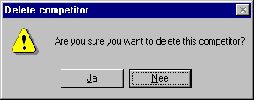
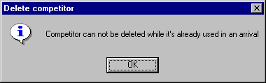
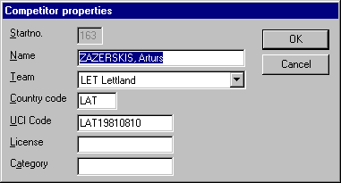
Use this to remove (a) selected competitor(s). A confirmation will be asked for. Competitors used in any classification can not be removed.
- Edit
Edit the selected competitor. Only one competitor can be selected to do this. Editing takes place with the help of the input screen, known from new input. The competitor number cannot be changed anymore at this point.
- Functions
Through this menu a competitors list can be pasted (page 28) from within a different application (Paste) and an intelligent mask can be applied (page 6) to the competitors list (Apply mask...).

Paste of competitors

Pasting of competitors can be done from within Office applications like Word and Excel. To do this, the data has to be ordered in a table and should have the order, known from the input screen for new competitors:
- Start no.
- Name
- Team name or code
- Country code
- UCI code
- License
- Category
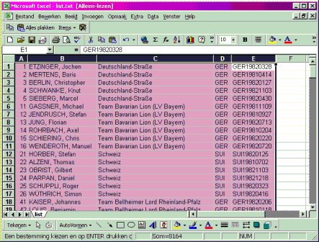
At the end, columns can be omitted.
Eventually, columns can be left empty.
To paste competitors: select the data in the source application and copy them to the Windows clipboard.
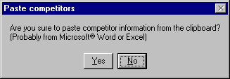
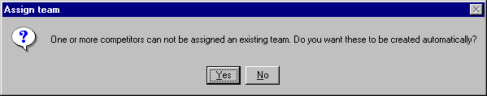
Press Paste in the Competitors window to actually paste the data into the StageRace file. A confirmation will be asked for. Existing data will be overwritten.

Teams

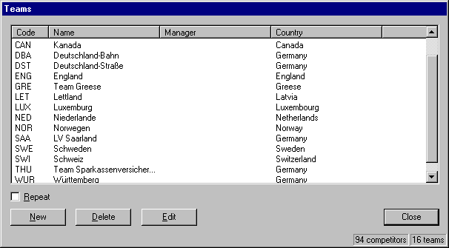
To edit the teams list, choose Edit|Teams..., double click Teams in the tree or click the appropriate standard tool bar icon.
The teams list window consists of the following items:
- The teams list
The width of the columns can be adjusted by dragging the little separation line between two column headers. The various columns can be rearranged by clicking on a column header and dragging it to the desired location, while [ALT] is pressed. By clicking on a column header, the list will be sorted on that particular column. By clicking the same column header more times, the sorting order will be reversed.
A team can be selected by clicking the particular row. A multiple selection can be made by holding down [SHIFT] or [CTLR] while clicking on the teams.
- New and Repeat
Whenever New is clicked, a window appears where the new team's data can be entered. At the moment of confirmation by clicking OK, the team will be added to the list. When the Repeat box is checked, new input will be requested, until entering of data is cancelled.
- Delete
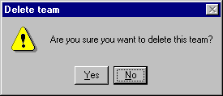
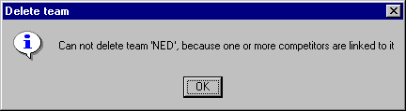
Use this to remove (a) selected team(s). A confirmation will be asked for. Teams to which competitors are assigned can not be removed.
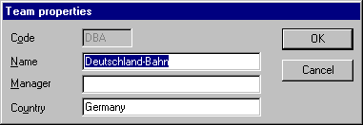
- Edit
Edit the selected team. Only one team can be selected to do this. Editing takes place with the help of the input screen, known from new input.

Time trial order

Before making a time trial classification (page 47), the starting order should be made available to the system.
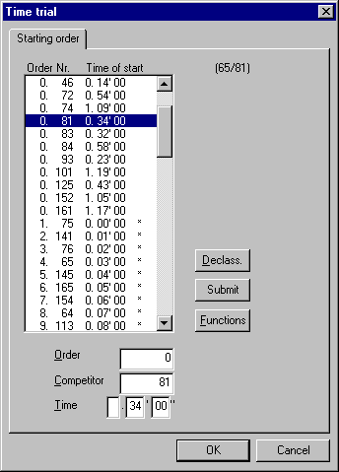
To do so, there is an item Starting order in the tree for every time trial. This item can be selected and after Edit|Edit selection... the starting order can be entered.
For every competitor one can enter starting order, start no. and eventual a starting time. This input can be confirmed with Submit.
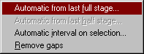
For one or several competitors, the order information can be removed with Declass..
The Functions buttons makes some supporting functions available:
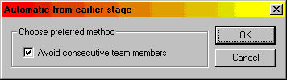
- With Automatic from last full stage... and Automatic from last half stage... a starting order will be determined automatically, based on the particular previous stage. In between a dialog will be displayed to choose for a more advanced sorting method. This because consecutive competitors from a same team can be avoided in the start list. In short, the lowest ranked competitor is always placed further down.
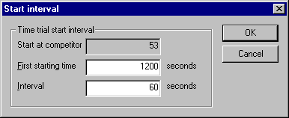
- With Automatic interval on selection... starting times can automatically be generated for the starting orders assigned. The starting time for the first competitor in the selection can be entered, plus the interval between all the selected competitors.
- Remove gaps checks the whole list and removes gaps, resulting in a list with successive starting orders only.
The list only consists of competitors which are actually available, as a result of previous stages. That's why this starting order can only then be drawn up after the previous stage has finished.
When competitors are already classified in the time trial to which a starting list applies, their starting time cannot be altered anymore. These competitors are marked in the list with an asterisk (*).
The button Insert order team captain vehicles (which is only visible for half stage communiqués) can be used to insert at the cursor position in the contents field a proposal order of team captain vehicles for the next stage, based on the current stage's arrival. The stage result of every team's best competitor is decisive for this order.

Data processing

Stage arrival

By choosing to edit a stage, a dialog window appears with one or multiple tab sheets.
The first tab sheet is always the arrival of the particular stage. Depending on the type of the stage, this tab sheets' type is Arrival (page 33) or Arrival time trial (page 47).
For the rest, this window consists of tab sheets for every bonus (page 10), points (page 11) and climb sprint (page 12) as configured for the particular stage. All these tab sheets are from the Arrival type (page 33).
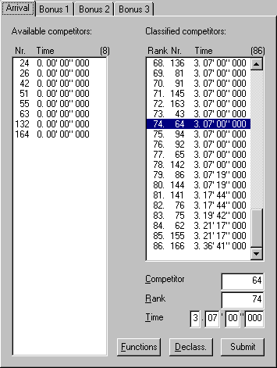
After confirmation of this dialog window with OK, all relevant classifications will be recalculated, in order to have the presentation frame up to date at all time.

Tab sheet Arrival
This tab sheet consists of two lists: available and classified competitors. The list of available competitors consists of all competitors who were not signed out neither dropped out at the start of the particular stage.
Competitors can move from the 'available' list to the 'classified' list by entering their start no. and ranking. When Submit is clicked, the data is submitted and the rider moves.
By selecting a competitor in the 'classified' list and pressing Declass., this competitor can be moved back to the 'available' list.
As follows, some facilities will be discussed, which arrange an eminent improved comfort of use. A lot of attention is paid to this tab sheet, because it is going to be used at the most critical moment of the entire event: the arrival.
- As soon as a rider is classified, it will be automatically suggested to assign the first following rider entered with the successive ranking. This way one only has to enter the start no. and eventually time (after the first competitor has been entered).
- When a rider is clicked in either one of the two lists, its data will be copied into the edit boxes in order to edit it quickly.
- Note that a large number of competitors can be entered easily by one hand only, using the numeric keypad of the keyboard.
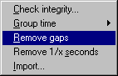
- Multiple riders from the 'classified' list can be selected (use [SHIFT] and [CTRL] keys, combined with the mouse). All selected riders can be declassed simultaneously. Also all selected riders can be given a new time at the same moment.
- Riders finishing in a bunch are all given the same time (2.3.040). Because of this there is through the button Functions a function Group time available. With this, all competitors with less then 1s, 2s or 3s distance will be given the time of that group's number one.
- Also through the Functions button, a classification can be imported. A source file has to be chosen, after which a confirmation dialog (page 35) appears. If a known file type such as the OPTIc or ChronX file format is chosen, the software automatically uses the specific import settings for these formats. For other file types, the rather advanced Import classification (page 35) window appears. Currently available classification information will be overwritten. Note that from imported files only the first 64kb at maximum will be read in order to prevent the system from what appears to be a system hangup when (accidentally) importing a very large file. This will cause no limitations on the functionality since files of such size are not to be expected.
- Also through the Functions button, there is the possibility to remove gaps in the rankings. This way, the classified competitors list with its current order is taken, where the competitors are given successive rankings, starting from 1.
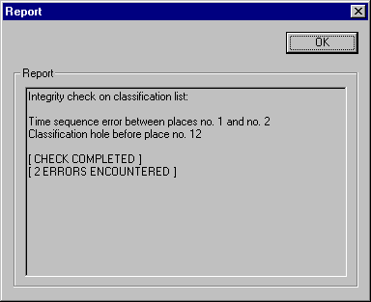
- Also through Functions, one can choose to round all the times of the classified competitors up to a full second, in only one operation.
- Functions also offers a function to check the integrity of the entered data. Gaps in the rankings as well as discrepancies in times will be considered here.

Confirm classification import

This dialog appears between the moment of selecting a file to import classification data from and the moment of actually reading the file from disk and proceeding with the import.
The appearance of this dialog can be switched off through Tools|Options.
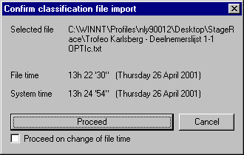
The dialog shows the chosen file name as well as its file time in order to decide whether the most recent version is available already. As a reference the current system time is shown.
As soon as the file satisfies the expectations, the Proceed button can be used. Cancel terminates the import.
Proceed on change of file time will happen StageRace to proceed automatically on the very first change to the file time that occurs.

Import classification

The Import classification window appears after a source file to import a classification from, has been chosen.
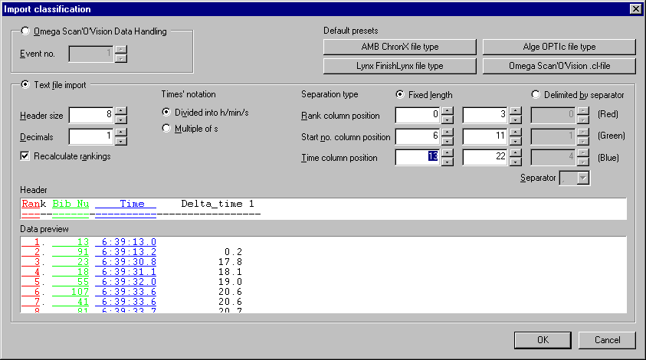
Because it's not possible to determine unambiguous how to treat the source files, a number of informations is asked for in this window.
First one has to choose for the file type between:
- Omega Scan'O'Vision Data Handling
- Text file import
When Data Handling from Omega® Electronics' Scan'O'Vision is chosen, an event number has to be entered, because these files often consist of various races.
When the rather general Text file import is selected, the following informations have to be entered:
- Header size: the number of lines that is entered here will be ignored at the top of the source file, as a header. This header is visible in the Header field. The remaining part of the source file - which will be processed - is visible in the Data preview field
- Decimals: the accuracy (in decimals) in which the rider's time is provided in the file
- Recalculate rankings: if not checked, the rankings will be taken from the source file. If checked, the rankings will be recalculated, looking at the rankings and times from the source file. With this function, gaps in the rankings from the source file can be overcome
- Times' notation: choose whether times in the file are provided as a formatted string of the h/mm/ss form or a multiple of seconds
- Separation type: choose between files with fixed columns (stuffed with spaces) or columns separated by special characters
- In case of fixed columns, choose the positions of the columns ranking, start no. and time: for every column the start and end position can be entered. These settings are visible at the bottom of the window by use of the coloured underlined text from the source file
- In case of delimited by separator, choose the positions of the columns ranking, start no. and time in respect of the column numbering of the file
- In case of delimited by separator, choose the separator type (a tab stop, or characters like comma, semi-colon, etc.)
In order to quickly retrieve default presets for known file types, buttons have been added to the upper right corner of the dialog.

Import file types

Scan'O'Vision file format

Omega® Electronics is the part of the world famous watches manufacturer and is among other things specialized in the development of top-end equipment for sports timing.
One of Omega® Electronics' products is the Scan'O'Vision finish camera.
The software that comes with this camera generates (under the name Data Handling) a number of text files, which consist of competitors’ information and classifications.
Data Handling files can typically be found in the \osvcolor\dh folder.
StageRace competitors in Scan'O'Vision
StageRace can generate all Data Handling files for an event.
In order to have StageRace generating such output files, the Export competitors for Omega Scan'O'Vision option in the Tools menu has to be chosen.
The following files will be generated:
- LstCat.txt: list of categories
- LstConc.txt: list of competitors
- LstLong.txt: list of race lengths
- LstNat.txt: list of nations or clubs
- LstRace.txt: list of events
- LstStart.txt: list of starters
- LstStyle.txt: list of race types
- LstTitPr.txt: list of race names for printing
These files contain the entire event; ergo all stages. Furthermore there are a number of five additional events foreseen, including all competitors, to be used for testing.
To configure the Data Handling in Scan'O'Vision, please refer to the appropriate documentation.
Scan'O'Vision results in StageRace
To import start numbers and timing results, the file LstRslt.txt is of interest. The file is composed as follows.
The file's first line consists of a description of the fields. All following lines correspond to the results of one single competitor at one particular measurement point.
Ergo, the file can consist of classifications of multiple measurement points ("events"). Thus one event will have to be chosen before importing.
Next, every line consists of:
- Event number
- Round, heat and lap
- Competitor's number
- Lane and status
- Time in units
- Formatted time in hh:mm.ss.tttt of which accuracy and rounding depend on Scan'O'Vision settings
The only fields of interest for StageRace are event number, competitor's number and time in units.
A typical file looks like this:
"Event";"Round";"Heat";"Lap";"Bib";"Lane";"idStatus";"Time";"Result"
1; 1; 1;9999;" 15"; 0; 1; 60451;" 7.046 "
1; 1; 1;9999;" 45"; 0; 1; 50453;" 5.046 "
1; 1; 1;9999;" 12"; 0; 1; 80458;" 7.046 "
1; 1; 1;9999;" 21"; 0; 1; 70461;" 8.046 "
2; 1; 1;9999;" 45"; 0; 1; 339882;" 33.989 "
2; 1; 1;9999;" 21"; 0; 1; 340231;" 34.024 "
2; 1; 1;9999;" 15"; 0; 1; 340242;" 34.025 "

To configure the Data Handling in Scan'O'Vision, please refer to the appropriate documentation.
Scan'O'Vision results in StageRace using .cl files
Besides the Data Handling functionality, also classification files (.cl) from Scan'O'Vision can be used for the transfer of results to StageRace. The important disadvantage of these files is the layout being dependent on view settings inside Scan'O'Vision. Therefore, the layout of these files is very varying and so they have to be imported though the Import classification (page 35) window.

OPTIc file format

Alge-Timing, with a worldwide net of distributors is a specialist for sports timing with 30 years of experience on timing consultancy, development and production.
Alge OPTIc is a computerized color photo finish system with integrated evaluation software. The Color Line Scan Camera scans every movement on the finish lane in true color and high resolution.
In cooperation with Alge the StageRace program has been made capable to generate files for and process files from OPTIc.
StageRace competitors in OPTIc
As further described in the OPTIc help files, text file import is possible (Import competitor list...), after which imported competitors immediately can be used in the race being judged.
In order to have StageRace generating such output files, the Export competitors for Alge OPTIc option in the Tools menu has to be chosen with the intended half stage being selected.
The location of the files generated depends on the settings in Options.
Output is generated in the form of a so-called tab separated file of which the file name is set up as follows:
[Race Title] - Competitors list [FS]-[HS] (OPTIc).txt
For instance:

Ronde van Nederland - Competitors list 3-1 (OPTIc).txt
Every line in the file consists of:
- Competitor's number
- Competitor's name and nationality (for operator convenience only)
A typical file looks like this:
1 DEKKER, Erik RAB
2 DEN BAKKER, Maarten RAB
3 VAN BON, Leon RAB
4 BOOGERD, Michael RAB
5 DE JONGH, Steven RAB
6 VIERHOUTEN, Aart RAB
7 SÖRENSEN, Rolf RAB
8 WAUTERS, Marc RAB
11 ANDREU, Frankie USP
12 HAMILTON, Tyler USP
13 DEAN, Julian USP
14 HINCAPIE, George USP
15 JOACHIM, Benoît USP
16 JONKER, Patrick USP
17 VANDEVELDE, Christian USP
18 VERMAUT, Stive USP
21 RODRIGUEZ, Fred MAP
22 BODROGI, Laszlo MAP
23 VAN HEESWIJK, Max MAP
24 HOSTE, Leif MAP
25 LEYSEN, Bart MAP
26 TANI, David MAP
27 PEETERS, Wilfried MAP
31 BLIJLEVENS, Jeroen POL
32 CASSANI, Enrico POL
33 CELESTINO, Mirko POL
36 MAZZOLENI, Eddy POL
37 SACCHI, Fabio POL
38 VOSKAMP, Bart POL
For OPTIc operation, please refer to the appropriate documentation.
OPTIc results in StageRace
Classifications made in OPTIc are available automatically in tab separated text format.
This data can be found in a .txt file of which the name is equal to the one of the race (.rac) being subject.
Within StageRace, the tab sheet Arrival (page 33) provides file import through the functions button. In the Import classification dialog the file can be picked, containing the classification data. Additionally, the file type in this dialog should be set to "Alge OPTIc Results" in order to have StageRace bypassing the advanced import preview dialog (page 35) and directly importing the OPTIc data.
For OPTIc operation, please refer to the appropriate documentation.

FinishLynx file format

Lynx System Developers, Inc. from Massachusetts, U.S.A., is a privately-owned company that supplies the latest results generation and handling technology to the sporting industry. The company employs software and hardware engineers and has its own production division to meet the growing worldwide demand for the Lynx range of digital sports data generation tools.
FinishLynx® is their popular photo finish and timing system. E.g., various of such systems are used at le Tour de France for intermediate timing as well as for finish.
The StageRace program has been made capable to generate files for and process files from FinishLynx®.
StageRace competitors in FinishLynx®
As further described in the FinishLynx® help files the database file can be modified or entirely replaced ("How Do I Create My Own Database Files?"), after which imported competitors immediately can be used in the race being judged.
In order to have StageRace generating such output files, the Export competitors for Lynx FinishLynx option in the Tools menu has to be chosen.
The location of the files generated depends on the settings in Options.
Output is generated in the form of a so-called comma-delimited file with the typical file name lynx.evt.
Two types of lines can be determined in the file:
- Event descriptions
Defined by FinishLynx® as follows:
<event number>, <round number>, <heat number>, <event name>
Used by StageRace as follows:
<stage number>, <half stage number>, 1, <half stage name> (<event name>)
- Descriptions for all competitors corresponding to the latest Event description
Defined by FinishLynx® as follows:
, <ID>, <lane>, <last name>, <first name>, <affiliation>
Used by StageRace as follows:
, <start no.>, 0, "<name>", "-", "<team name>"
Stage number, half stage number and start no. are actually used by FinishLynx® to work properly. Additional fields are provided for operator convenience only. Note that heats and lanes aren't used.
A typical file looks like this:
1,1,1,1999-08-26 Stage 1 (12. Trofeo Karlsberg)
,1,0,"ETZINGER, Jochen","-","Deutschland-Straße"
,2,0,"MERTENS, Boris","-","Deutschland-Straße"
,3,0,"BERLIN, Christopher","-","Deutschland-Straße"
,4,0,"SCHWANKE, Knut","-","Deutschland-Straße"
,5,0,"SIEBERG, Marcel","-","Deutschland-Straße"
,11,0,"GASSNER, Michael","-","Team Bavarian Lion (LV Bayern)"
,12,0,"JENDRUSCH, Stefan","-","Team Bavarian Lion (LV Bayern)"
,13,0,"JUNG, Florian","-","Team Bavarian Lion (LV Bayern)"
,14,0,"ROHRBACH, Axel","-","Team Bavarian Lion (LV Bayern)"
,15,0,"SCHIERING, Chris","-","Team Bavarian Lion (LV Bayern)"
,16,0,"WENDEROTH, Manuel","-","Team Bavarian Lion (LV Bayern)"
,21,0,"HORBER, Stefan","-","Schweiz"
,22,0,"ALZENI, Thomas","-","Schweiz"
,23,0,"OBRIST, Gilbert","-","Schweiz"
,24,0,"PARPAN, Daniel","-","Schweiz"
,25,0,"SCHUPPLI, Roger","-","Schweiz"
,26,0,"WÜTHRICH, Simon","-","Schweiz"
2,1,1,1999-08-27 Stage 2 (12. Trofeo Karlsberg)
,1,0,"ETZINGER, Jochen","-","Deutschland-Straße"
,2,0,"MERTENS, Boris","-","Deutschland-Straße"
,3,0,"BERLIN, Christopher","-","Deutschland-Straße"
,4,0,"SCHWANKE, Knut","-","Deutschland-Straße"
,5,0,"SIEBERG, Marcel","-","Deutschland-Straße"
,11,0,"GASSNER, Michael","-","Team Bavarian Lion (LV Bayern)"
,12,0,"JENDRUSCH, Stefan","-","Team Bavarian Lion (LV Bayern)"
,13,0,"JUNG, Florian","-","Team Bavarian Lion (LV Bayern)"
,14,0,"ROHRBACH, Axel","-","Team Bavarian Lion (LV Bayern)"
,15,0,"SCHIERING, Chris","-","Team Bavarian Lion (LV Bayern)"
,16,0,"WENDEROTH, Manuel","-","Team Bavarian Lion (LV Bayern)"
,21,0,"HORBER, Stefan","-","Schweiz"
,22,0,"ALZENI, Thomas","-","Schweiz"
,23,0,"OBRIST, Gilbert","-","Schweiz"
,25,0,"SCHUPPLI, Roger","-","Schweiz"
3,1,1,1999-08-28 Stage 3.1 (12. Trofeo Karlsberg)
,1,0,"ETZINGER, Jochen","-","Deutschland-Straße"
,2,0,"MERTENS, Boris","-","Deutschland-Straße"
,3,0,"BERLIN, Christopher","-","Deutschland-Straße"
,4,0,"SCHWANKE, Knut","-","Deutschland-Straße"
,5,0,"SIEBERG, Marcel","-","Deutschland-Straße"
,11,0,"GASSNER, Michael","-","Team Bavarian Lion (LV Bayern)"
,12,0,"JENDRUSCH, Stefan","-","Team Bavarian Lion (LV Bayern)"
,13,0,"JUNG, Florian","-","Team Bavarian Lion (LV Bayern)"
,14,0,"ROHRBACH, Axel","-","Team Bavarian Lion (LV Bayern)"
,15,0,"SCHIERING, Chris","-","Team Bavarian Lion (LV Bayern)"
,16,0,"WENDEROTH, Manuel","-","Team Bavarian Lion (LV Bayern)"
,21,0,"HORBER, Stefan","-","Schweiz"
,22,0,"ALZENI, Thomas","-","Schweiz"
,23,0,"OBRIST, Gilbert","-","Schweiz"
,25,0,"SCHUPPLI, Roger","-","Schweiz"
3,2,1,1999-08-28 Stage 3.2 (12. Trofeo Karlsberg)
,1,0,"ETZINGER, Jochen","-","Deutschland-Straße"
,2,0,"MERTENS, Boris","-","Deutschland-Straße"
,3,0,"BERLIN, Christopher","-","Deutschland-Straße"
,4,0,"SCHWANKE, Knut","-","Deutschland-Straße"
,5,0,"SIEBERG, Marcel","-","Deutschland-Straße"
,11,0,"GASSNER, Michael","-","Team Bavarian Lion (LV Bayern)"
,12,0,"JENDRUSCH, Stefan","-","Team Bavarian Lion (LV Bayern)"
,13,0,"JUNG, Florian","-","Team Bavarian Lion (LV Bayern)"
,14,0,"ROHRBACH, Axel","-","Team Bavarian Lion (LV Bayern)"
,15,0,"SCHIERING, Chris","-","Team Bavarian Lion (LV Bayern)"
,16,0,"WENDEROTH, Manuel","-","Team Bavarian Lion (LV Bayern)"
,21,0,"HORBER, Stefan","-","Schweiz"
,22,0,"ALZENI, Thomas","-","Schweiz"
,23,0,"OBRIST, Gilbert","-","Schweiz"
,25,0,"SCHUPPLI, Roger","-","Schweiz"
4,1,1,1999-08-29 Stage 4 (12. Trofeo Karlsberg)
,1,0,"ETZINGER, Jochen","-","Deutschland-Straße"
,3,0,"BERLIN, Christopher","-","Deutschland-Straße"
,4,0,"SCHWANKE, Knut","-","Deutschland-Straße"
,5,0,"SIEBERG, Marcel","-","Deutschland-Straße"
,11,0,"GASSNER, Michael","-","Team Bavarian Lion (LV Bayern)"
,12,0,"JENDRUSCH, Stefan","-","Team Bavarian Lion (LV Bayern)"
,13,0,"JUNG, Florian","-","Team Bavarian Lion (LV Bayern)"
,14,0,"ROHRBACH, Axel","-","Team Bavarian Lion (LV Bayern)"
,15,0,"SCHIERING, Chris","-","Team Bavarian Lion (LV Bayern)"
,16,0,"WENDEROTH, Manuel","-","Team Bavarian Lion (LV Bayern)"
,21,0,"HORBER, Stefan","-","Schweiz"
,22,0,"ALZENI, Thomas","-","Schweiz"
,23,0,"OBRIST, Gilbert","-","Schweiz"
,25,0,"SCHUPPLI, Roger","-","Schweiz"
For FinishLynx® operation, please refer to the appropriate documentation.
FinishLynx® results in StageRace
Classifications made in FinishLynx® are available automatically in comma-delimited text format (when using the default settings).
This data can be found in a .lif file of which the name is equal to the one of the event (.evn) being subject.
Within StageRace, the tab sheet Arrival (page 33) provides file import through the functions button. In the Import classification dialog the file can be picked, containing the classification data. Additionally, the file type in this dialog should be set to "Lynx FinishLynx Results" in order to have StageRace to retrieve the proper settings for the import preview dialog.
Since time precision is dependent on software settings, the layout of the .lif files is slightly varying and so they have to be imported though the import preview window (page 35).
For FinishLynx® operation, please refer to the appropriate documentation.

ChronX file format

AMB i.t. specializes in the design, manufacturing and support of sports timing and scoring systems.
Their Cyclip system is specifically designed for the identification and timing during cycling events. For an unlimited number of competitors it is possible to give positions, best lap times, numbers, names etc. This information can be presented on a scoreboard, computer or TV screen and can be printed during and after the race or practice.
ChronX is AMB's timing software for both professional and club racing. It is designed for use with all TranX Pro systems, Tranx260, TranX160, AMB130 and Cyclip systems.
In cooperation with AMB the StageRace program has been made capable to generate files for and process files from ChronX.
StageRace competitors in ChronX
As further described in the ChronX User Manual, text file import is possible, with as result imported competitors appearing in the Competitor Database.
This database is organised with a division into multiple classes, each containing a number of competitors forming a whole. Therefore StageRace output is generated in such a way that the starting list for every distinct half stage will appear in ChronX as a different class. This allowing the operator to quickly choose the right set of competitors for a race.
In order to have StageRace generating such output, the Export competitors for AMB ChronX option in the Tools menu has to be chosen with the intended half stage being selected.
The location of the files generated depends on the settings in Options.
Output is generated in the form of a so-called Comma-Separated Values (CSV) file of which the file name is set up as follows:
[Race Title] - Competitors list [FS]-[HS] (ChronX).txt
For instance:

Ronde van Nederland - Competitors list 3-1 (ChronX).txt
Every line in the file consists of:
- Competitor's number
- Competitor's name, nationality, team and UCI code (for operator convenience only)
- Transponder no.
- Class name
Transponder no. for the time being equals the starting number of the competitor. Later on it will be made possible to enter the transponder numbers within StageRace already. One way or the other, competitor numbers can appear in the exported files. In that case, the Transponder Translation Table should be used to make the connection between competitors and their transponders.
Class name has the following format:
Competitors list [FS]-[HS] ([Race Title])
For instance:
Competitors list 3-1 (Ronde van Nederland)
A typical file looks like this:
1,"DEKKER, Erik","",1,"1","Competitors list 3-1 (Ronde van Nederland)","NED","Rabobank","NED19700821"
2,"DEN BAKKER, Maarten","",2,"2","Competitors list 3-1 (Ronde van Nederland)","NED","Rabobank","NED19690126"
3,"VAN BON, Leon","",3,"3","Competitors list 3-1 (Ronde van Nederland)","NED","Rabobank","NED19720128"
4,"BOOGERD, Michael","",4,"4","Competitors list 3-1 (Ronde van Nederland)","NED","Rabobank","NED19720528"
5,"DE JONGH, Steven","",5,"5","Competitors list 3-1 (Ronde van Nederland)","NED","Rabobank","NED19731125"
6,"VIERHOUTEN, Aart","",6,"6","Competitors list 3-1 (Ronde van Nederland)","NED","Rabobank","NED19700319"
7,"SÖRENSEN, Rolf","",7,"7","Competitors list 3-1 (Ronde van Nederland)","DEN","Rabobank","DEN19650420"
8,"WAUTERS, Marc","",8,"8","Competitors list 3-1 (Ronde van Nederland)","BEL","Rabobank","BEL19690223"
11,"ANDREU, Frankie","",11,"11","Competitors list 3-1 (Ronde van Nederland)","USA","US Postal Service","USA19670926"
12,"HAMILTON, Tyler","",12,"12","Competitors list 3-1 (Ronde van Nederland)","USA","US Postal Service","USA19710301"
13,"DEAN, Julian","",13,"13","Competitors list 3-1 (Ronde van Nederland)","NZL","US Postal Service","NZL19750128"
14,"HINCAPIE, George","",14,"14","Competitors list 3-1 (Ronde van Nederland)","USA","US Postal Service","USA19730629"
15,"JOACHIM, Benoît","",15,"15","Competitors list 3-1 (Ronde van Nederland)","LUX","US Postal Service","LUX19760114"
16,"JONKER, Patrick","",16,"16","Competitors list 3-1 (Ronde van Nederland)","NED","US Postal Service","NED19690525"
17,"VANDEVELDE, Christian","",17,"17","Competitors list 3-1 (Ronde van Nederland)","USA","US Postal Service","USA19760522"
18,"VERMAUT, Stive","",18,"18","Competitors list 3-1 (Ronde van Nederland)","BEL","US Postal Service","BEL19751022"
21,"RODRIGUEZ, Fred","",21,"21","Competitors list 3-1 (Ronde van Nederland)","USA","Mapei - Quick Step","USA19730903"
22,"BODROGI, Laszlo","",22,"22","Competitors list 3-1 (Ronde van Nederland)","HUN","Mapei - Quick Step","HUN19761211"
23,"VAN HEESWIJK, Max","",23,"23","Competitors list 3-1 (Ronde van Nederland)","NED","Mapei - Quick Step","NED19730203"
24,"HOSTE, Leif","",24,"24","Competitors list 3-1 (Ronde van Nederland)","BEL","Mapei - Quick Step","BEL19770717"
25,"LEYSEN, Bart","",25,"25","Competitors list 3-1 (Ronde van Nederland)","BEL","Mapei - Quick Step","BEL19690210"
26,"TANI, David","",26,"26","Competitors list 3-1 (Ronde van Nederland)","ITA","Mapei - Quick Step","ITA19691008"
27,"PEETERS, Wilfried","",27,"27","Competitors list 3-1 (Ronde van Nederland)","BEL","Mapei - Quick Step","BEL19640710"
31,"BLIJLEVENS, Jeroen","",31,"31","Competitors list 3-1 (Ronde van Nederland)","NED","Team Polti","NED19711229"
32,"CASSANI, Enrico","",32,"32","Competitors list 3-1 (Ronde van Nederland)","ITA","Team Polti","ITA19720215"
33,"CELESTINO, Mirko","",33,"33","Competitors list 3-1 (Ronde van Nederland)","ITA","Team Polti","ITA19740319"
36,"MAZZOLENI, Eddy","",36,"36","Competitors list 3-1 (Ronde van Nederland)","ITA","Team Polti","ITA19730729"
37,"SACCHI, Fabio","",37,"37","Competitors list 3-1 (Ronde van Nederland)","ITA","Team Polti","ITA19740522"
38,"VOSKAMP, Bart","",38,"38","Competitors list 3-1 (Ronde van Nederland)","NED","Team Polti","NED19680606"
For ChronX operation, please refer to the appropriate documentation.
ChronX results in StageRace
As further described in the ChronX User Manual, text file export is possible, which can be used for classification generation in StageRace.
A run should be selected within ChronX and Current Race Results being chosen from the menus. A file name can be chosen.
Within StageRace, the tab sheet Arrival (page 33) provides file import through the functions button. In the Import classification dialog the file can be picked, containing the classification data. Additionally, the file type in this dialog should be set to "AMB ChronX Results" in order to have StageRace bypassing the advanced import preview dialog (page 35) and directly importing the ChronX data.
For ChronX operation, please refer to the appropriate documentation.

Tab sheet Arrival Time Trial

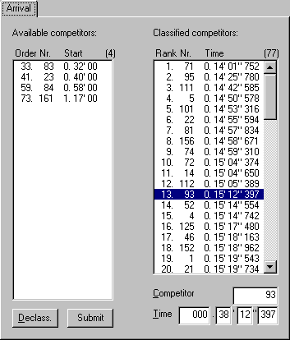
The tab sheet Arrival Time Trial looks like the tab sheet Arrival (page 33) in many respects.
The most important difference is the absence of the ranking field, since this is automatically calculated from the times entered.
Pay attention to enter absolute times, thus times since the departure of the first rider. After all, the difference in departure times is already known from the Time trial order (page 31) dialog. All this makes it easy to do the timing of a time trial event; only one time base is needed to give all competitors their time.
In contrast to normal stages, the times of a time trial will be given in 1/1000th of a second.

SignOuts

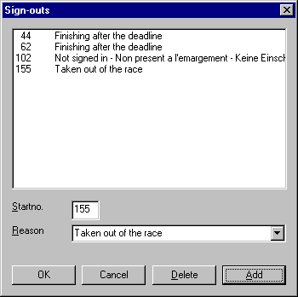
When a half stage is selected in the tree frame, a list with sign-outs can be edited through SignOuts in the Insert menu.
In the appearing window, start no. and reason of sign-out can be entered. The idea is to insert competitors here who were signed out before the departure of the particular half stage. Riders who drop out should not be administrated as signed out, but will automatically be printed as drop-out on bottom of the classification. Possibly they can be brought up as sign-out at the next half stage.
The SignOuts window always remembers the ten most recently used sign-out reasons.

Communiqués

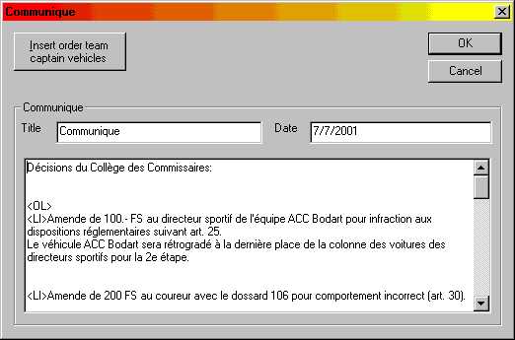
Whenever an event, stage or half stage is selected in the tree frame, a communiqué can be added through Communique in the Insert menu.
In the appearing window, title, date and contents of the communiqué can be entered. The title field can be used to give the communiqué an identification number, but this is not necessary since StageRace gives communiqués the number of the (half) stage or the indication "general" for respectively (half) stages and the entire event.
Communiqués can be edited by selecting the particular communiqué in the tree frame and choosing Edit selection... from the Edit menu.
Communiqués can be removed by selecting the particular communiqué in the tree frame and choosing Delete communique... from the Insert menu.
The button Insert order team captain vehicles (which is only visible for half stage communiqués) can be used to insert at the cursor position in the contents field a proposal order of team captain vehicles for the next stage, based on the current stage's arrival. The stage result of every team's best competitor is decisive for this order.

Publications

Cross out list

Often, cross out lists are experienced by members of the jury as a pleasant tool, to be used during the race.
These lists can be generated by choosing Update cross out lists from the Edit menu. The cross out lists for all stages will be generated instantly than.
All competitors competing in the event, are stated on the cross out list. For the competitors not starting in a stage concerned (signed out or not finished), the frame is coloured black.
Every row in the sign out list corresponds to the competitors of the team, stated at the left side of the row. If, of course, competitors with their start no. in the same decade are also part of the same team, as entered in the competitors list.
Note that no cross out lists are generated for time trials.

Page Setup

By choosing Page Setup in the File menu, it is possible to influence the lay out of the printed publications. Possible Page Setup choices are:
- Paper size, paper feed and print orientation: these settings are taken from the default settings in the driver of the selected printer.
- Margins in millimetres
- Headers and footers: here you can type a header or footer. The header will be printed at top of the page and the footer at the bottom of the page. When particular information has to be printed as part of the header or footer, the following characters can be used within the text.
&w Window title
&u Page address (URL)
&d Date in short notation (as set in the International Settings in the Control Panel)
&D Date in long notation (as set in the International Settings in the Control Panel)
&t Time in the format as set in the International Settings in the Control Panel
&T Time in 24 hour format
&p Number of current page
&P Total number of pages
&& The and-sign (&)
&b The text immediately following these characters will be printed centered
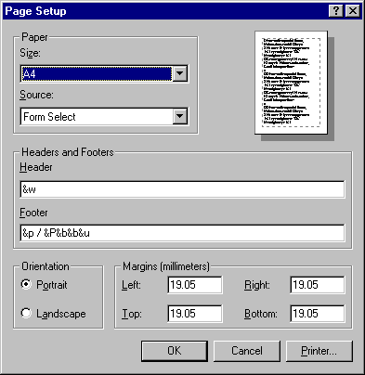
&b&b The text following the first '&b' printed centered and the text following the second '&b' printed right aligned

Registration

Hardware key

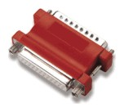
StageRace software is protected by use of a hardware key.
A hardware key is a piece of electronics; matchbox sized. This key has to be connected to your computer. Every modern computer is equipped with such a printer port, also referred to as LPT port.
An eventual printer connected, can subsequently be connected to the hardware key. Both can then use the same printer port, without trouble.
StageRace uses a well known brand hardware keys of excellent quality. Whenever the key does not want to work together with your peripheral equipment, please contact your computer dealer. Over the past five years there are no problems known to Totaal Software, arising from the use of this particular type of hardware keys.
Make sure that the hardware key is connected to your printer port and that StageRace is installed correctly. Next, you can check your hardware key's properties in the Help menu's About box.
When your hardware key is recognized by StageRace, you'll find this information in the particular window:
- Detected "Totaal" key no. 12345... (with the unique code of the particular key)
- STAGERAC V2.00 27-09-1999 (with the maximal version number for which the particular hardware key is suitable, including the date of issuance of the key)
When your hardware key is not recognized by StageRace, you'll find this information in the particular window:
- Invalid or missing hardware key
- No registration information available
Ergo, hardware keys for StageRace have an internal version number. Keys can be updated in the future, in order to let you use more up to date program versions.

Original illustration obtained from Alladin® Knowledge Systems

Adresses

Web site: www.stagerace.com
E-Mail: support@stagerace.com (technical support)
E-Mail: sales@stagerace.com (registration)
E-Mail: feedback@stagerace.com (ideas for product improvement)
Telephone number: (31) 06-50908248
Mail address: (no visitor without appointment)
Att. A. Verhagen, BSc
Peperstraat 2
6127 AS Grevenbicht/Born
the Netherlands
The use of E-Mail is preferred

License agreement

The software product being the subject here, can only be used after confirmation of the following license agreement.

License
You are given a free license to use this evaluation software product. By confirming this license agreement a legal agreement will be realized between you and Sander Verhagen (to be called StageRace from this point on).
By installing, copying or otherwise using this software product, you agree to be bound by the terms of this license agreement. Other provisions can be taken care of in a separate agreement between you and StageRace.

General

This software product is protected by copyright laws and international copyright treaties, as well as other intellectual property laws and treaties. All rights which are not declared in this document are reserved.
You have the freedom to install and evaluate it on as many computers as you like, for evaluation purposes only. You are not allowed to bring copies of this software product, which are running in evaluation mode, into action, other than for evaluation purposes.
In evaluation mode, the saving and printing functions will be switched off. To discontinue the evaluation mode, you are obligated to obtain a hardware key from StageRace for which you can contact at sales@stagerace.com.

Limitations

You may not reverse-engineer, de-compile or disassemble this software product.
You may not sell, rent or lease this software product.
You may not make any modifications to this software product.

No liability

You agree to accept this software product "as is" without warranty of any kind. The entire risk arising out of use or performance of this software product remains with you.

Support

Example files

A few example files are included in the StageRace distribution.
The version 2000.1.20 distribution includes the following stage events:
- Ronde van Nederland - Netherlands Tour, elite event, 2001 edition
- GP General Patton, German juniors event
- Ronde van Nederland - Netherlands Tour, elite event, 2000 edition
- Trofeo Karlsberg, German juniors event
At these events, StageRace is actually used in practice, with an exception for the last one. The file Trofeo Karlsberg.str as a test has been growing aside with the development of StageRace, based on the original classifications for which we were involved in the realization, even before the existence of StageRace.
From all events the export files are included for ChronX and OPTIc. For Scan'O'Vision and FinishLynx® the file names are fixed, so that the files for these can only be applied to one event. Therefore Ronde van Nederland 2001.str has been chosen.
All example files have the Read only property, so that a user in evaluation mode cannot mess up the example files by accident. This can sometimes be notified by StageRace; please ignore these messages.

Support

We're pleased to give you all possibilities to get the most out of the StageRace software. These possibilities are based on the fact that we are very willing to help, but also to do this as efficient as possible. To do so, some 'rules of the game' have been drawn up, where it concerns getting support.
- For questions you are initially directed to the online help functions and the StageRace web site. Whenever questions are asked which can easily be answered by use of these resources, we will redirect you to them.
- We cannot give you any support on the use of Microsoft® Windows® nor on the general organisation of stage races. Whenever you want to get support, you will have to be informed about these subjects.
- All first line support takes place in written correspondence. Namely: ordinary post, E-Mail or web site. We will always try to send an answer within one week after the question has been received.
- We can be stand by on telephone during your event. However, this should be arranged in writing on beforehand. You will possibly be charged for this, all depending on the particular situation.
- All support will normally be given in Dutch or English, to choose by the customer. At verbal support possibly German can be used as well. This all depends on the particular support representative and can never be claimed as a right.
The only support that is bought with the program are the online help functions. All other forms of support are based on a wish to supply you with as much service as possible, unless otherwise explicitly agreed on. Ergo, this support can be suspended at any time and no claims can be made to it.

Feedback

We hope the StageRace products to become leading in their class. That's why we want these products to be as complete as possible. Furthermore it is naturally that these applications have to work as spotless as possible.
Your help is indispensable for that. Please give your propositions, experiences, etc.
You can give your suggestions by written correspondence. Namely: ordinary mail, E-Mail or internet site.
We will do a maximum effort to process al your ideas into the next version. In case of serious problems or errors, a new version will be released as soon as possible. For this it is of the uppermost importance to provide us with your experiences!
Also have a look at: Error messages (page 58)

Error messages

Of course it is always a bad thing to happen when a computer application stops early and quits with a (usually vague) error message.
To turn such unpleasant experience into at least something positive, we kindly request you to log all details in such situations, to help fixing the cause in future versions.
- In Windows® 9x: a brief message is given, but through Details you can get more information on the error message. Select the contents of the details window and copy them to the clipboard. Paste the clipboard contents to a text file or e-mail and send the printed text file or the e-mail to Totaal Software
- In Windows® NT/2000: an error message is given with at least one so-called hexadecimal number (recognized from the "0x" at the front end of the numbers). File at least all hexadecimal numbers (for instance "0x00416320"), but preferably the entire message and send it to Totaal Software
Sending can be done to our mail address or at development@stagerace.com directly.

Service documents

In order to serve registered users as good as possible, we can provide some additional documents.
The following subjects are involved:
- A full overview of the features of StageRace
- Introduction and reference on the window messages used to enable real-time communication between StageRace and other software products
- An overview of the various event rules, classification types and calculation methods, as they are provided by StageRace
- An instruction for composing personal style sheets for StageRace-documents
Some of these documents are already available, while others are still currently being prepared. Feel free to contact support@stagerace.com.

UCI compliance

During the design of StageRace, there have not been any official contacts with the International Cycling Union (UCI, abbreviated).
Nevertheless, with StageRace it has been tried to be completely compliant to the current UCI rules, as freely available at the start of the 2000 season.
Wherever this applies in these help documents, there is referred to these rules. This is done by stating the number of the particular articles between brackets and coloured red. It then always concerns articles from part II Road Races.
Other knowledge has been retrieved from other sources.
Together with one of the leading sports timing companies in Benelux and Germany, a considerable amount of know-how has been gained about time keeping and jury administration of stage races. Therefore StageRace is build...
- from many years of experience in road cycling,
- with two years of practical experience on (stage) races in the Netherlands and Germany,
- in cooperation with the leading manufacturers of time keeping equipment, and
- after consultation of jury members and officials of the unions KNWU (Netherlands), BDR (Germany) and UCI (international).

Miscellaneous

Options

The Options dialog window provides the following functions:
- Choose between the available help languages.
- Choose to suppress the dialog that is being shown on StageRace startup, in case of a missing hardware key (page 52).
- Choose to show the Confirm classification file import (page 35) dialog.
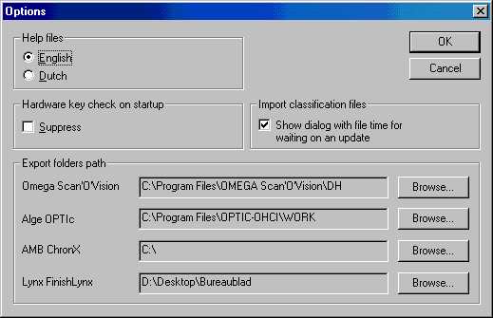
- Choose the location where to place exported StageRace files (look at Omega Scan'O'vision, Lynx FinishLynx, Alge OPTIc and AMB ChronX).

Registry entries

The following system registry keys are in use by StageRace:
HKEY_CLASSES_ROOT\StageRace.Document
Various keys, names and values in order to provide file open, print and print to through direct command and DDE commands.
HKEY_CURRENT_USER\Software\Totaal Software\StageRace
\Export paths | Alge OPTIc  AMB ChronX  Lynx FinishLynx  Omega Scan'O'Vision | Paths for exporting files  (see page 60)
\Import | Choose file dialog default type | The default file type in the import file picker dialog
 | Decimals  Event  Generate rankings  Header size  Import type  Rank column  Rank end  Rank start  Separation type  Separator  StaNo column  StaNo end  StaNo start  Time column  Time end  Time notation  Time start | All the settings in the import classification dialog  (see page 35)
\ListCompetitors | ColumnOrder  ColumnWidth | List control preferences for Competitors list  (see page 26)
 | Repeat | Check box setting for adding repeatedly  (see page 26)
\ListTeams | ColumnOrder  ColumnWidth | List control preferences for Teams list  (see page 29)
 | Repeat | Check box setting for adding repeatedly  (see page 29)
\MainFrame | IsIconic  IsZoomed | Main frame appearance
 | WindowRect | Main frame appearance
\Sign-outs\Reasons | 0  1  2  3  ... | Reasons for a maximum of ten sign-outs  (see page 48)
HKEY_LOCAL_MACHINE\SOFTWARE\Microsoft\Windows\CurrentVersion\Uninstall\StageRace
 | DisplayName |  | Name appearing in Software from Control Panel  E.g.:  "StageRace (Totaal Software)"
 | UninstallString |  | Command line for uninstalling StageRace  E.g.:  C:\WINNT\IsUninst.exe -f"C:\Program Files\StageRace\Uninst.isu"
HKEY_LOCAL_MACHINE\SOFTWARE\Totaal Software\StageRace
 | HelpLanguage |  | Help language setting
 | ShowImportFileCheckDialog |  | Setting whether wait dialog before importing files should be displayed  (see page 60)
 | SuppressHardwareKeyCheck |  | Setting to suppress the additional hardware key message box on startup
Personally making changes to the Windows® register is reserved for very experienced users!

Undo

StageRace does not support Undo.
Nevertheless, changes made in dialog windows can be undone by choosing Cancel.
The only exception for this are the windows for competitors and teams, which then again only have the choice Close. All changes done in these windows are final. Nevertheless, before every change, a confirmation will be asked for.

Tools

Time calculator
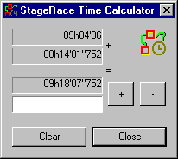
StageRace comes with the Time calculator tool.
With this tool times can be added and subtracted, quickly and easy.
Pay attention that the times have to be entered from the left to the right side. Thus first tens of hours, then hours, tens of minutes, minutes, etcetera. The maximal accuracy is 1/1000th of a second, in accordance with StageRace.
With the buttons + and -, the operation can be executed.
With the subtraction of times, the order of the entered times is not important, since the result will always be given as a positive result.

Speed calculator
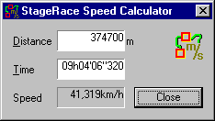
StageRace comes with the Speed calculator tool.
With this tool speed can be calculated quickly and easy from distance and time.
Pay attention that the times have to be entered from the left to the right side. Thus first tens of hours, then hours, tens of minutes, minutes, etcetera. The maximal accuracy is 1/1000th of a second, in accordance with StageRace.
The distance has to be entered in meters.
The result will always be given with an accuracy of five digits in total, either before or after the decimal comma.

